**[Decentralise Party](https://x.com/DecentraliseP)**

[@DecentraliseP](https://x.com/DecentraliseP)

**ARTICLE: KHAZARIAN PROMISED LAND & THE UNDEAD MASHIACH.** ***“We will return this territory, and build the Great Khazaria – the Jewish state –on these fertile lands the same way as, 50 years ago, we created Israel.”*** -**Mashiach, Menachem Mendel Schneerson, 1994.** The **Rebbe** and living Mashiach of **Chabad Mafia** was the leader of the Jewish people from 1951-1994. He is considered to be the most influential Jewish figure for centuries. **Schneerson** considered more than **Jerusalem** and G**reater Israel** as an ancestral homeland; the Rebbe had a strong affinity with his **Ashkenazi** roots as he was born in **Ukraine** in 1902. He wished to return to this **'Promised Land'** to act as the Global capital for the **Kingdom of Jews.** In a 1994 address featured in the Vologda-based publication **Slavyanin,** Menachem Mendel Schneerson detailed his intentions to obliterate both **Ukraine** and **Russia.** “*Slavs, and among them Russians – are the most unbending people in the world. Slavs are unbending as a result of their psychological and intellectual abilities, created by many generations of ancestors. It is impossible to alter these genes. Slav, Russian, can be destroyed, but never conquered. That is why this seed is subject to liquidation, and, at first, a sharp reduction in their numbers.* *First of all, we will divide the Slavic nations into small countries with weak and severed connections. For this, we will use our old method: Divide and conquer. We will try to pit these countries against each other, and suck them into civil wars for the sake of mutual destruction.* *The Ukrainians would think that they are fighting against the expansionist Russia and struggling for their independence. They will think that they have finally gained their freedom, while they become fully subdued by us. The same will be thought by Russians, as though they defend their national interests to return their lands, “illegally” taken away from them, and so on.”* *Looking back in history, it must be admitted that these lands are the ancient ancestral lands of the Jewish* ***Khazaria,*** *that is Israel, captured by Kiev’s Rus’ (the ancient state of Russia with the capital in Kiev) in the tenth century.* *The Slavs are temporary guests on these lands and are subject to eviction. We will return this territory, and build the* ***Great Khazaria*** *– the Jewish state –on these fertile lands the same way as, 50 years ago, we created* ***Israel,*** *squeezing the Palestinians out. Israelis will partially relocate here, and we will drive Slavic cattle out far to the north, beyond Moscow.* *There will be a small Northern Territory, a reservation with a compact population — a reservation, like Indian reservations in America..."* Schneerson discusses a resurgent **Khazar empire**; the **Chabad Lubavitch** intends to relocate from New York to **Dnepropetrovsk**, disregarding the scripture and prophecy of **Zionism** and Israel. The Lubavitchers maintain a bastardised scriptural view, recognising Menachem Mendel Schneerson, who passed away in New York in 1994, as **Moshiach.** **The Jews believe he will resurrect from the grave using Jewish Kabbalah and necromancy.** (See Necromancy in Judaism: [https://x.com/DecentraliseP/status/1790020089535954969…](https://x.com/DecentraliseP/status/1790020089535954969)) A temple was erected in **Dnepropetrovsk** for the undead Schneerson's enthronement, situated within the Chabad **"Menorah"** centre, a vast complex and the largest of its kind in Europe. Consequently, the Lubavitchers no longer anticipate Moshiach's arrival in Israel. They harbour no desire to associate with the authentic Promised Land. **Which begs the question, is Israel a distraction?** Israel and **Netanyahu** are openly sacrificial lambs in this agenda, seemingly only serving the purpose of igniting the **“Great War”** required to resurrect Mendel Schneerson. A confidential Netanyahu aide, as cited by The **Times of Israel,** explains the Israeli government's pursuit of a substantial Israeli settlement in Ukraine: ***“You have to expect us to exercise our historical rights somewhere else. We decided this will be on the shores of the Black Sea, where we were an autochthonous people for more than 2000 years. Even the great non-Zionist historian Simon Dubnow said we have the right to colonise Crimea. It’s all in the history books. You can look it up”.*** **How can they achieve their goal of returning to Ukraine?** The Lubavitch, backed by **George Soros**, facilitated the Maidan revolution, having already repurposed Ukraine to cater to affluent Jews in the 1990s. Precipitating from these events, came the war in Ukraine. Upon the war's commencement, Jewish Prime Minister **Zelensky** enforced a ban on Ukrainian men between 18 to 60 years old from leaving the country, consigning them against the Russians; simultaneously an exodus of **Ukrainian Jews** to Israel was permitted. **After these successes, Crimea became a focus for the Jews.** As early as 1945, Crimea has been a target for the Jews, particularly when an impoverished Stalin nearly sold the entire peninsula to Jewish financiers. Presently, Putin stands in the way of the **Ashkenazi** dream, having annexed Crimea in 2014. Crimea’s significance is such, there is no peace deal without Crimea being gifted back to Eastern Ukraine. Crypto-Jew **Boris Johnson** scuppered a peace deal because it didn’t include Crimea. **Why is Crimea so significant?** Khazaria was a medieval trading nation that flourished for approximately 300 years before its obliteration in the 11th century. Its geographical span encompassed southern Russia and extended to the Crimean Peninsula. In the ninth century, Khazars had stretched from Astrakhan and the Caspian Sea to the Dnieper, encompassing Crimea, and the **White Tower** outpost in the north, which engendered the name of the **Białowieża Forest.** These are the origins of the **Ashkenazim Jews**, so their ancestral homeland must be repossessed and Crimea is the first step towards reclaiming **Khazaria.** Approximately 80 – 90% of the world’s Jews are Ashkenazi, so it would seem logical many of them would choose Ukraine over the false ‘Semitic’ narrative of Israeli Jews. Rabbi of Dnepropetrovsk **Shmuel Kaminetski** said: ***“We have lived together with the Ukrainians for 1000 years. Ukraine is our Land.”*** Apparently, Lubavitchers do not wish to have anything to do with the genuine Promised Land and would rather ressurrect the **'living Mashiach',** who would go on to take the throne in the coming Messianic era as an **Undead King.** Treachery is in the Chabad spirit. Thanks for reading.

**Traduire** le **post**

[[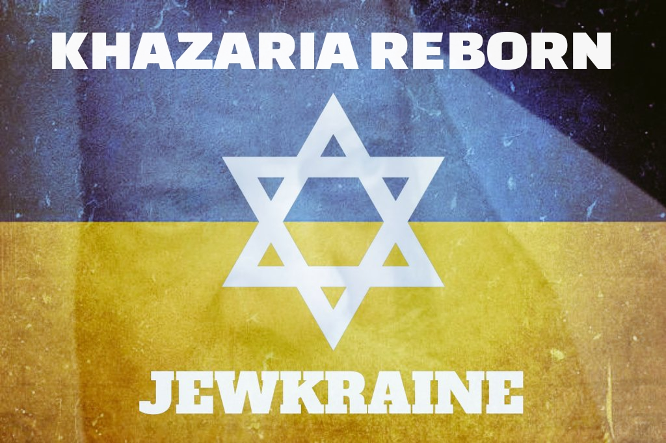](https://x.com/DecentraliseP/status/1795040610661073114/photo/1)](https://x.com/DecentraliseP/status/1795040610661073114/photo/1)

[12:33 PM · 27 mai 2024](https://x.com/DecentraliseP/status/1795040610661073114)

·

**355,1 k**

vues